CENWP-OD-B
29 June 2009
MEMORANDUM FOR THE RECORD

SUBJECT: Dead chinook at Bonneville’s Adult Fish Facility (AFF).

On 29 June at approximately 1200, CRITFC researchers reported a dead chinook in the AFF to Project Fisheries. The fish appeared to be in decent condition with some net marks and possibly a pinniped mark, but no apparent cause of death. The fish had been sampled. Information collected is provided below.

- Species – Chinook
- Origin – unclipped
- Length – 75.5 cm
- Weight – Unknown
- Marks and Injuries noted during tagging – NA
- Marks and Injuries found on the carcass – Possible net and pinniped marks.
- Cause and Time of Death – about 1200, unknown cause.
- Future and Preventative Measures – NA
- Other –

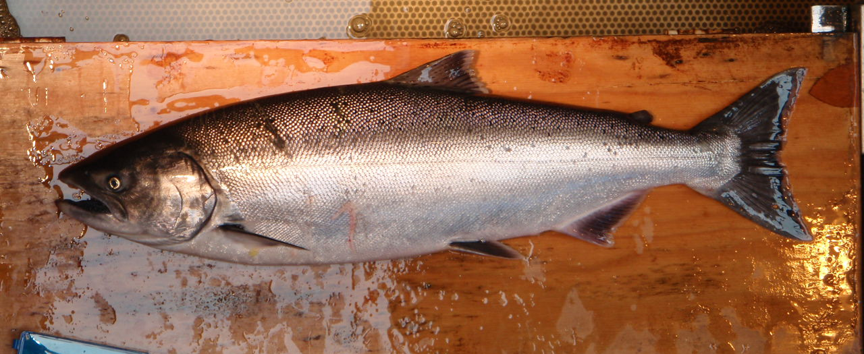
29 June 2009 Dead Chinook.
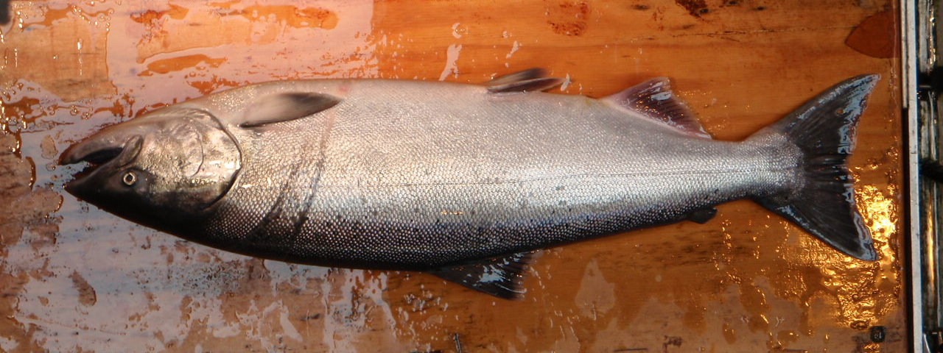
29 June 2009 Dead Chinook- other side.

Bonneville Fisheries

